In the initial results, there was clear overfitting, so we added a Dropout layer to reduce the overfitting.

We also used the LeakyReLU activation function.

We set the random_state =0.

And do not forget that the dimensions of the convolutional neural network(CNN) have been changed, as well as the filters, the kernel_size, the strides, the pool_size, and the dimensions of the connected neural network(NN) have been modified.

These modifications led to a decrease in overfitting, an increase in validation accuracy, and a decrease in loss.

As we will see later in the results:

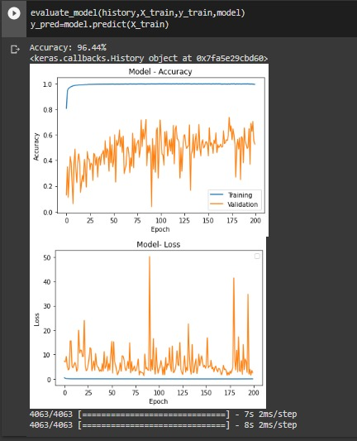

Figure(1): Show Training Accuracy Before Processing is 96.44%.

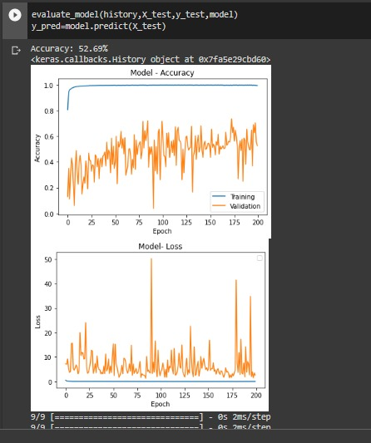

Figure(2): Show Validation Accuracy Before Processing of 52.69%.



Figure(3): Show Modl Training Accuracy & Validation Accuracy Before Processing Convolutional Neural Network(CNN).



Figure(4): Show Modal Loss and Validation Loss Before Processing convolutional neural network(CNN).

We notice the presence of overfitting throughout the training epoch.

But after we made the modifications, the desired goal was reached, as we will see now:

Accuracy improvement.

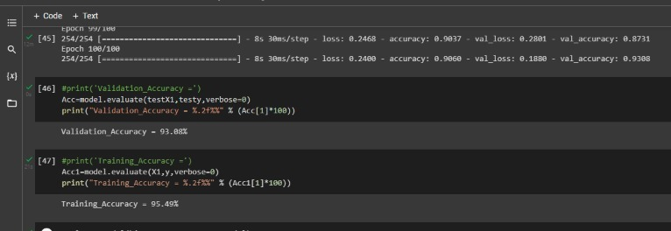

Figure (5) shows the result of the Validation Accuracy (93.08%) & Training Accuracy(95.49%).

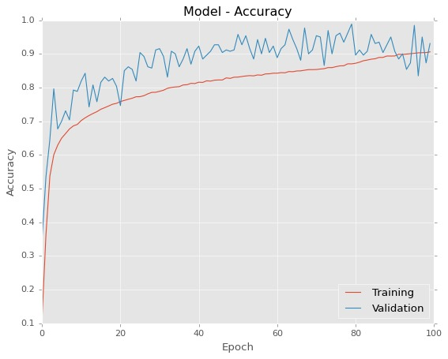

Figure (6) shows the relationship between Validation Accuracy & Training Accuracy.

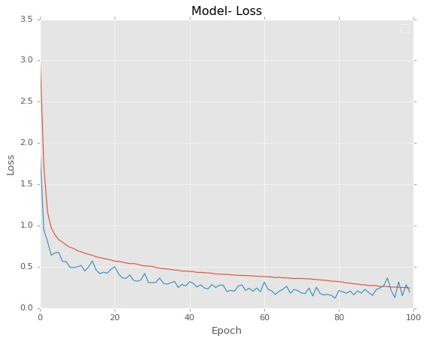

Figure (7) shows the relationship between Loss & Epoch.

We notice the disappearance of overfitting throughout the training epoch, This is what we strived for.